CCS Rule  
  
Selector – Whatever rules are applied are applied for all the elements with that selector.

+ open and closed curly braces

+ CSS declaration that consists in two parts: property and values. Property defined by CSS, there are pre-defined values. It has a colon and a semicolon at the end.

A CSS rule can have several zero or more declarations at the same time.

The collection of the CSS rules is the stylesheet.

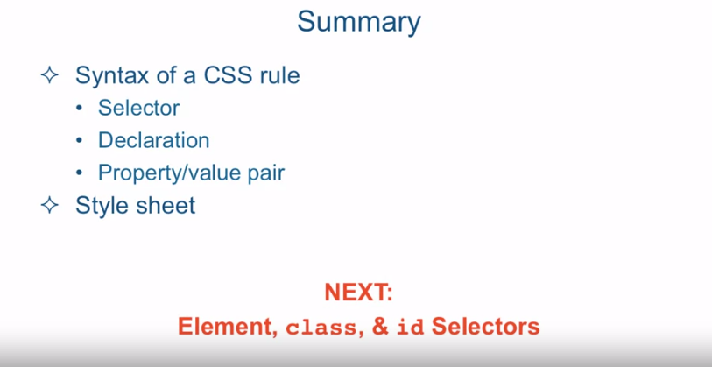

[SOUND]

>> CSS works by associating

rules with HTML elements. These rules govern how the content of

specified elements should be displayed. And while styling an entire web page

could be a pretty complex process, defining a simple CSS rule

is fairly straightforward. So, let's go over that. A CSS rule consists of selector,

in this case it's a p, the paragraph tag, which is basically saying that whatever

rules I'm about to give should apply to the content of every single paragraph

tag in the entire HTML page. The selector is followed by open and

close curly braces. Inside of those braces,

we have CSS declaration. And it consist of two parts,

the property and the value. Property name is something that's

predefined by CSS specification, and for every property there is a set

number of pre-defined values. Or in the case of numerical values, set number of type of numerical

values that is pre-defined. Now, every property in the value

is separated by a colon, and is terminated by a semicolon. Now, technically speaking,

a semicolon is not a requirement, but it's a best practice, and

you should always, always use it. Now, as I told you, a CSS rule can

consist of several declarations. For example, in this case we're specifying

the contents of the paragraph tags in our HTML page should have a particular

color, a particular font size, and also be a particular width,

meaning the paragraph itself, the content, should take up 200 pixels. Now, the collection of these CSS

rules is what's called a style sheet. Now, technically speaking, you don't have to have anything in the

style sheet to be called a style sheet. An empty style sheet,

it technically is a style sheet as well. But it's just not a very useful one. So, obviously, you would have

at least one CSS rule in there. But, typically,

you have way more than just one. Okay, here I am in sublime text and I'm

looking at a file called css-syntax.html and it's located in

the examples/Lecture12 folder. Let me give you a quick rundown of

the structure of the HTML that we have. So, in this HTML document we have

a heading, h1, a couple of h2s, and a couple of paragraphs in between

signified by the p paragraph tag. And what we'll want to do is give

these elements some custom styling. So, I'm going to place the styling, our style sheet, straight in the head

section of our HTML document. Now, in later lecture we'll talk about

where CSS styles should really go for a real world website. But for now, for convenience sake, we'll just put it

straight in the head part of the document. So, here we see a paragraph

tag that's being targeted. And we're going to change it's color to

blue, font size to 20, and width 200, which means it will contain an area

of the screen that's 200 pixels wide. Our heading one tag, h1,

we're going to give it a color of green, we'll bump up it's font

size a little bit and we'll also tell it to align itself

in the middle of the screen. So, let's take a look at what this

page looks like in the browser. As you could see, our h1 tag is in

the middle of the screen, and it's green. And the two paragraphs that we have are

blue and only take up around 200 pixels. And already, right away,

you could see the power of CSS. We only specified

the paragraph tagged once, and yet every paragraph in the document

is styled exactly the same. So, it affords us consistency and

also efficiency is writing CSS code. Now, I do want to point out one quick but

important thing. If you take a look at this subheading 1,

and then subheading 2, you can see that it is bold and it's a little

bit bigger than the regular text would be. Now, where did that style come from? I certainly never specified what

kind of styling to apply to, essentially, what is an h2 tag. Well, that styling came

from the browser itself. Every browser comes with some default

styles that it applies to different HTML elements. And h1, h2, and so on, and different other elements are very

commonly styled by the browser itself. So, a lot of the times it's your

job to really reset, or override, these styles and put the styles in that

you would like your webpage to have. So, to summarize,

we went over the syntax of a CSS rule. We talked about the selector part,

declaration part and the property value pair. We also talked about combining the CSS

rules into one to create a style sheet. Next, we're going to zero in on the one

part of the CSS rule declaration, and that is the selector. We're going to talk about

different types of selectors. In particular, element,

class and ID selectors.